Lab Assignment 19.1

CH.SUMANTH – 2303A51889

Python to Java Conversion
Task:
Translate a simple Python class into Java using AI assistance. Instructions:
  - Prompt AI to convert a Python class with attributes and methods into equivalent Java code.
  - Verify that constructors, method signatures, and data types are properly handled.
  - Run both versions (Python & Java) to compare expected outputs. Expected Output:
  - Equivalent working Java class translated from Python.
Screenshots:
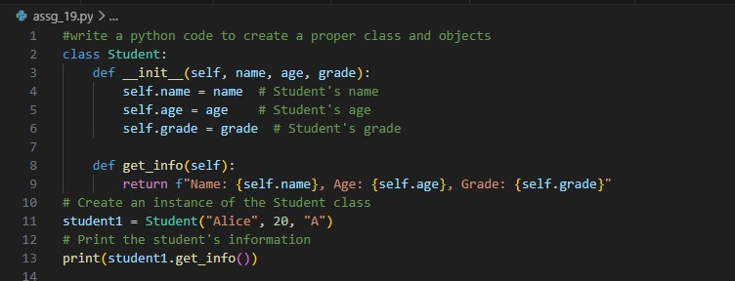

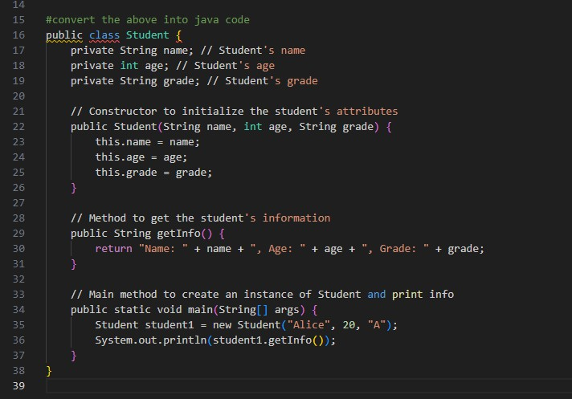
Output:

C++ to Python Function Conversion
Task:
Convert a C++ function for factorial calculation into Python. Instructions:
  - Ask AI to translate a recursive C++ factorial function into Python.
  - Validate correctness by testing with sample inputs.
  - Ensure Python version follows Pythonic conventions. Expected Output:
  - A correct Python implementation equivalent to the original C++ factorial function.
Screenshots:

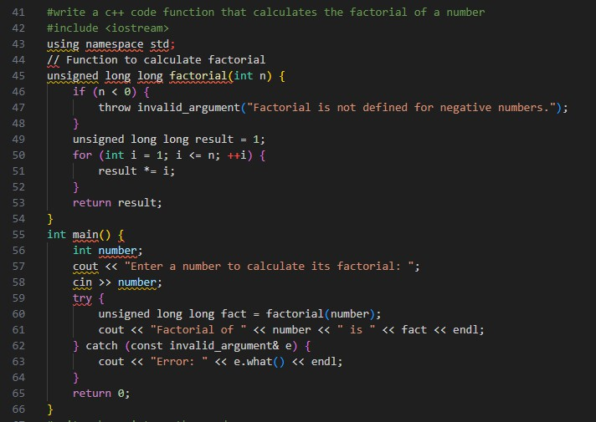
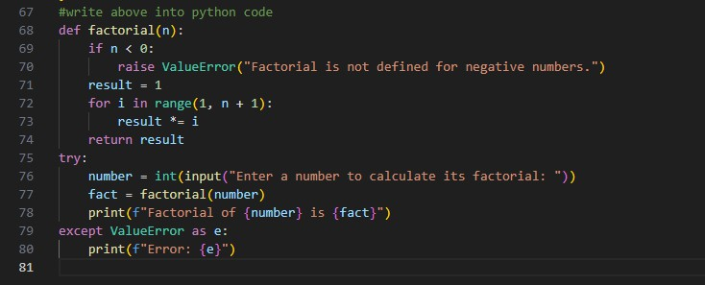
Output:
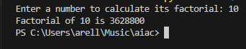

SQL to Pandas Query
Task:
  - Translate a SQL query into a Pandas DataFrame operation in Python. Instructions:
  - Provide AI with a SQL query (e.g., SELECT name, salary FROM employees WHERE salary > 50000).
  - Ask AI to generate equivalent Pandas code.
  - Test the generated code on a sample DataFrame. Expected Output:
  - Equivalent Pandas query that retrieves the correct subset of data.
Screenshots:
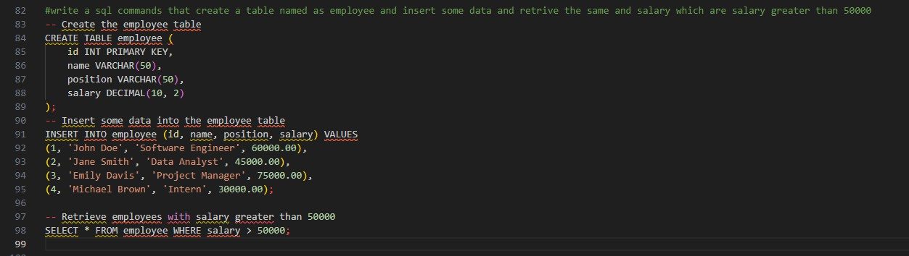
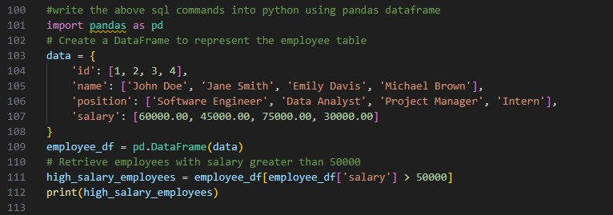

Output:
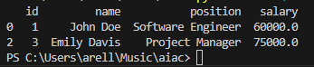

Real-Time Application: Multi-Language Snippet Converter
Scenario:

  - Students will choose a real-time use case where they need code in multiple languages.
Example:
  - Converting a Python web scraping snippet into JavaScript for browser automation.
  - Translating a Java method into C# for enterprise applications. Instructions:
  - Prompt AI to translate code between two chosen languages.
  - Test both implementations to ensure they produce the same results.
  - Document challenges faced during translation (e.g., syntax, libraries). Expected Output:
  - Working equivalent code snippets in at least two different programming languages.
SCREENSHOTS:
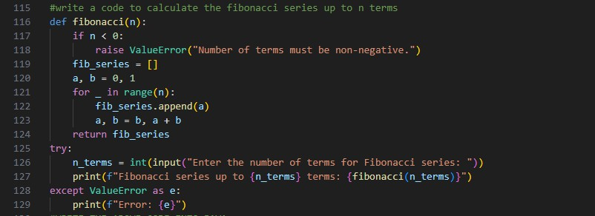

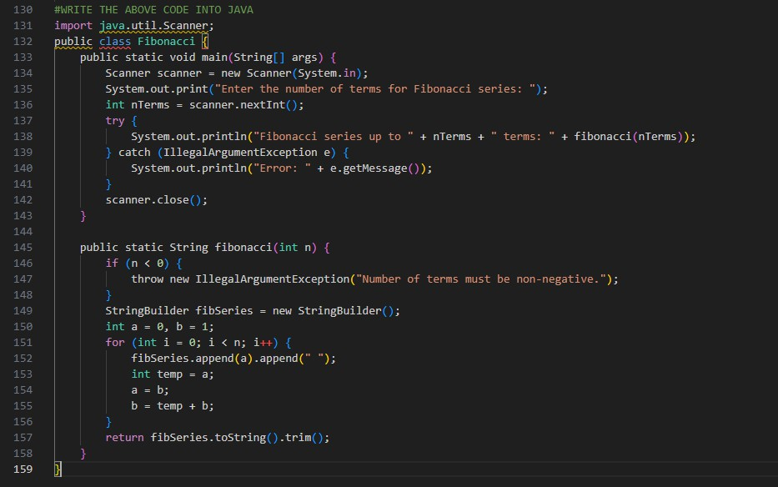

Output:
